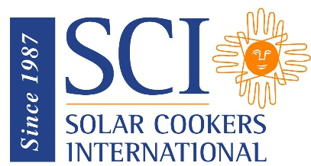
Exploratory Resident Survey for Solar Cooking

Based on Food and

Agriculture Organization survey
Goal of assessment: to determine if solar cooking is an expressed, felt need by the residents in a specific refugee or IDP settlement
Instructions to person conducting the survey:
- Interview the primary cook in the household
- Give a brief description of solar cooking (a technology that captures free solar energy for cooking and making water safe to drink)
Survey questions:
A1. What do you consider to be the most important aspect of the stove you are using currently? (Probe: Easy to use, durable, portable, uses less fuel, cooks food well, was given to you for free)

A2. Does your drinking water need to be made safe to drink? (Probe: water is contaminated) (Yes, No)

A3. Do you sell or barter food to obtain fuel for cooking? (Yes, No)

A4. What fuels do you use for cooking? (Probe: charcoal, crop residues, dung, LPG, kerosene, wood, other – select all that apply)

A5. Are you experiencing problems with the current source of your cooking fuel? (Yes, No)

A6. What is the desired future for this community?

______________________________________________________________________________

Exploratory Resident Survey for
Solar Cooking, continued

B1. Do you cook indoors or outdoors? (Indoor, Outdoor, Both)
B2. How many people do you cook for each day? [number]

B3. How many meals do you prepare each day? (One, two, three, four, five or more)

B4. What time of day do you eat meals? (Probe: before dawn, morning, midday, evening, after sunset)

B5. Will your solar cooker be secure if you leave while you are cooking? (Yes, No)
______________________________________________________________________________
C1. For what reasons are you interested in using a solar cooker?

C2. Do you believe that you can make a solar cooker work? (Yes, No)

C3. Are you willing to change the way that you cook? (Yes, No)

C4. Are you willing to change the time of day that you prepare food? (Yes, No)

C5. Will you commit to attend a complete round of training sessions during several weeks? (Yes, No)

C6. Are you willing to be interviewed again in three months to give information about your solar cooking experience? (Yes, No)

C7. Are you willing to learn and train others? (Yes, No)

