THREE MILLION SOLAR COOKERS WORLDWIDE IMPACTING OVER ELEVEN MILLION PEOPLE

Caitlyn S. Hughes*, Julie L. Greene

Solar Cookers International, 2400 22nd Street #203, Sacramento, CA USA
email: Caitlyn.hughes@solarcookers.org, Julie.greene@solarcookers.org,
web: http://www.solarcookers.org/

Abstract: The need for an accurate assessment of solar cooking worldwide was identified at the Solar Cookers International (SCI) Global Convention 2014. The solar cooking sector requested that SCI determine the number of solar cookers that exist in the world. SCI compiled this information from published reports and its network of over 350 organizations and individuals. It is displayed in an interactive map on SCI’s website. The current count is over three million solar cookers known since 1990. Next steps involve gathering more detailed and up to date information including use rates, exact locations, distribution rates, and impact data. Disseminating this information further will help those within and outside of the sector gain a more accurate understanding of solar cookers worldwide, track progress, and advocate for solar cooking.

Keywords: solar cooker distribution, map, network

- INTRODUCTION

1.1. The need & SCI’s qualifications

The need for a more comprehensive assessment of the global status of solar cooking worldwide was identified at the Solar Cookers International Global Convention 2014 held in Sacramento, California, USA. The sector requested that SCI calculate the number of solar cookers that exist in the world. This would help the sector track progress, advocate with decision makers, acquire funding, and more.
Solar Cookers International was the ideal organization to conduct this research as the leader and convener of the solar cooking sector. The Monitoring and Evaluation Specialist position was created at Solar Cookers International shortly after that convention to research this and other topics. In addition to its proven sector leadership role leading, Solar Cookers International’s qualifications to conduct this research include its recent recognition as a top three finalist of the Interaction Data Quality Award. Interaction is a group of more than 180 humanitarian aid organizations.

- METHODOLOGY

2.1. Information sources

Solar Cookers International has established a network of over 350 solar cooking related individuals and organizations. From this network and additional sources, SCI has been gathering information on the work of these partners including the number of solar cookers that exist worldwide. This includes records of solar cookers that were handmade, sold, subsidized, or given for free.
One of the main sources of information for this research was the Solar Cookers International Wiki (www.solarcooking.org), the largest digital database of solar cooking related information. The Wiki platform allows the hundreds of individuals and organizations in the Solar Cookers International Network to create and update their own webpage with information including how many solar cookers they have made, sold, and/or distributed. In addition, Solar Cookers International has a team of webmasters who regularly monitor solar cooking related news, post it on the SCI Wiki, and initiate further communication. This map also includes information gathered from published reports. SCI staff and SCI Advisory Council members also gathered information from presentations and conversations at solar cooking conventions including the Solar Cookers International Global Convention 2014 in Sacramento, California, USA and ConSolFood 2016 at University Algarve in Faro, Portugal.
The number of people impacted by solar cookers was determined by taking the number of solar cookers distributed in each country and multiplying by the average household size of each country.

2.2. Platform

The Solar Cooker Distribution Map was created using a free online platform called CartoDB. This program was selected because of its price (free) and capability to display the information as an animation over time or categorize by type of solar cookers in addition to the format shown below. The map could also easily be embedded in SCI’s website, allowing for the most up to date information to be displayed. A Microsoft Excel spreadsheet can also easily be exported to allow for calculations and additional ways to share information. The radius of each circle on the map below is proportional to the number of solar cookers in that location.

  - Dissemination

After compiling and mapping the information, SCI distributed it through the SCI digital newsletter (the Solar Cookers International Digest) and made it publically available on its website. The online version at http://www.solarcookers.org/our-work/solar-cooker-distribution/ is interactive. The organization or individual name, exact number of solar cookers, and city name are visible when hovering the mouse over a particular location. The user can also zoom in or out on the map. A request for individuals and organizations to include and/or update their information accompanied this dissemination. A simple form for individuals and organizations to add or update their information is also available on that webpage.

- RESULTS

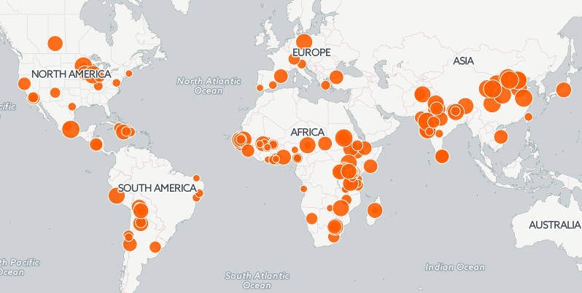

Figure 1. Distribution of solar cookers by number

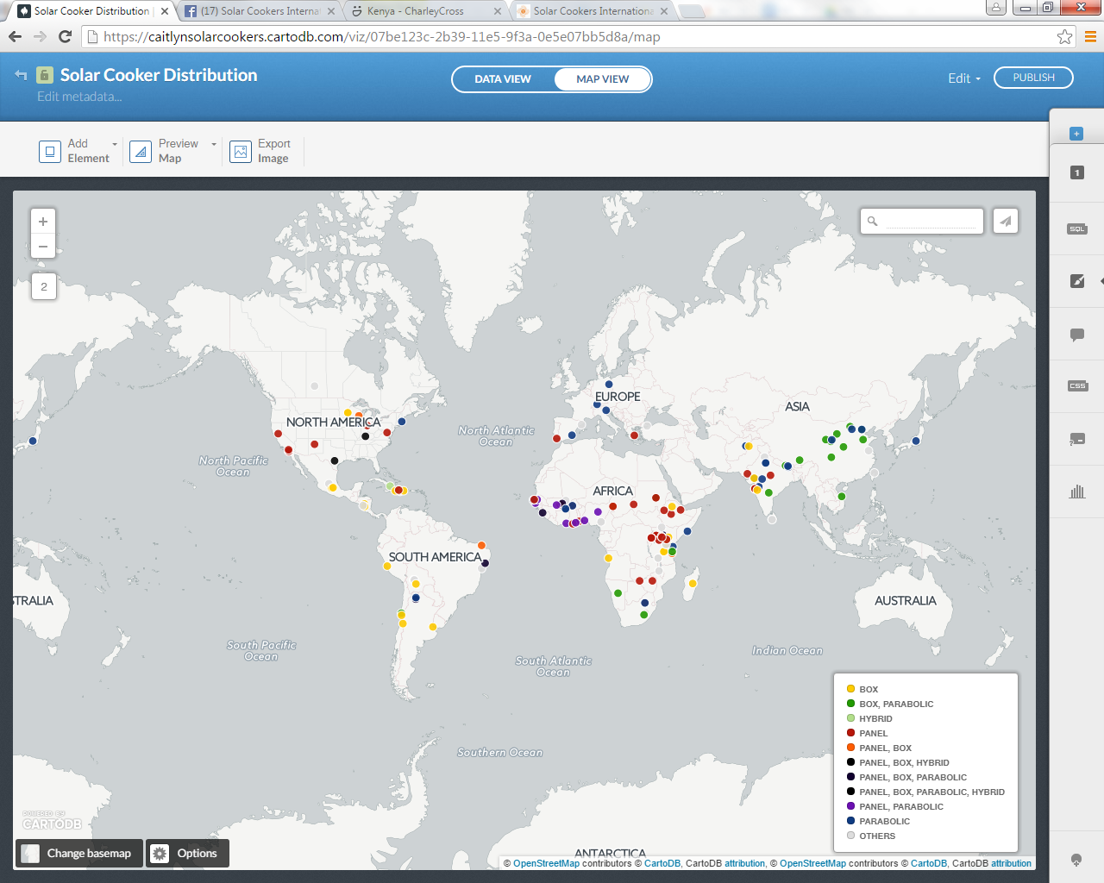

Figure 2. Distribution of solar cookers by type

Organization/Individual | Number
Afghanistan
Global Hope Network International | 338
SERVE | 22000
Angola
El Fuego de Sol | 20
Argentina
Inti-Sud Soleil | 473
SOLAR INTI | 3000
Fundacion EcoAndina | 250
Bolivia
CEDESOL Foundation | 7000
CECAM Bolivia | 120
Kyoto Twist | 310
Inti-Sud Soleil | 6387
Brazil
Jose Albano | 20
Oceanbyte Projects e Servicios | 50
Cozinha Escola Experimental Solar | 28
Burkina Faso
ACCEDES | 70
UNHCR, Caritas Burkina Faso, HELP | 601
DTC Business Women Micro-enterprise | 300
Union des Femmes pour le developpement (UFD) | 35
Tle Nafa/ACCEDES | 16
Cambodia
Global Roots/ Solar Cookers International | 1
Cameroon
Hai Min Pofti Cameroon | 252
Nkambe Rural Council | 28
Canada
Solar Freedom International Inc. | 3600
Chad
PROMOSOL (Center for the Promotion of Solar Energy) | 10
Tschad Solaire | 14000
Jewish World Watch | 128000
Chile
Canelo de Nos | 192
Inti-Sud Soleil | 2193
Delicias del Sol Restaurante Solar (Association of Solar Artisans of Villaseca) | 43
China
China Agricultural Statistics yearbook (Lanzhou) | 751000
China Agricultural Statistics yearbook (Beijing) | 23000
China Agricultural Statistics yearbook (Yinchuan) | 326000
China Agricultural Statistics yearbook (Lhasa) | 13000
China Agricultural Statistics yearbook (Hohhot) | 40000
China Agricultural Statistics yearbook (Chengdu) | 132000
China Agricultural Statistics yearbook (Jinan) | 16000
China Agricultural Statistics yearbook (Xining) | 230000
China Agricultural Statistics yearbook (Xi'an) | 86000
Mengyin Solar Cooker Project | 49400
Yancheng Sangli Solar Energy Industrial Co. Ltd | 80000
Huining Solar Cooker Project | 49400
Huzhu Tu Autonomous County Solar Cooker Project | 49400
Cuba
Grupo de Energias Renovables Aplicadas | 250
Dominican Republic
Solar Oven Partners | 75
Ethiopia
Partnership for Integrated Sustainable Development Association | 3700
Solar Cookers International | 3603
Sol Solidari | 238
Gambia
Rescue Mission Gambia | 9246
Germany
SK-12, SK-14 | 16000
Ghana
African King Foundation | 500
Paula Winchester | 100
Guinean Volunteers for the Environment (VGE) | 6
Greece
Aftarkeia | 100
Guinea
VGE | 976
Haiti
Kyoto Twist | 22
Power from the Sun | 40
Friends of Haiti Organization | 1657
SCI/Sun Ovens International /International Child Care Ministries/Programme Energie Solaire | 400
Haiti Solar Oven Partners | 5607
Clean Currents/Solar Cookers International | 100
India
Keshav Srushti | 23484
Applied Science and Engineering | 50
Shirdi Saibaba Temple | 73
various manufacturers IS 13429 | 505688
Brahma Kumaris World Spiritual University | 84
Haryana Renewable Energy Development Agency | 8312
Gandhi Ashram | 95000
Simplified Technologies for Life | 2044
M. Laxman and Co | 40
Barli Development Institute for Rural Women | 500
Zilla Parishad primary schools | 23
Ladakh Autonomous Hill Development Council | 650
Italy
Salvambiente Onlus | 100
Ivory Coast
VGE | 6
Japan
Amane | 3000
Kenya
Altener Energy | 30
Kyoto Energy Ltd. | 2000
Mwayeo Kenya | 40
Sustainable Utilization of Renewable Energy (SURE) | 718
Great Hope Orphanage | 3
TWR | 400
Samaritan's Purse | 40
Solar Cookers International | 7686
Tonembee Association | 860
Friends of the Old (FOTO) | 926
Mount Kenya Energy Project | 12
Haines Solar Cookers | 291
SCI (Sunny Solutions) | 3154
Lesotho
Bethel Business and Community | 350
Madagascar
Kyoto Twist | 22
Association pour le Développement de l’Energie Solaire | 4640
Malawi
Care and Support Network | 315
Mali
Kyoto Twist | 110
AFIMA | 3000
Sun for all | 5
VGE | 6
Mexico
Mixtec Children's Project | 100
Tolokatsin | 480
HotPot (Fondo Mexicano para la Conservacion de la Naturaleza/Solar Household Energy) | 25000
Namibia
Namib Desert Environmental Education Trust (NaDEET) | 488
Nepal
Foundation for Sustainable Technologies | 2500
Vajra Foundation Nepal | 13000
Rotary/Centre for Rural Technology | 136
Nicaragua
Nicarguaun Solar Oven Project/New Energy Works Timberframers/Victor-Farmington Rotary Club | 290
Las Mujeres Solares de Totogalpa | 22
Phoneix Group | 500
Solar Oven Society | 300
Fuprosomunic/Project Gettysburg Leon | 1122
Nigeria
VGE | 6
Cosmopolitan Women Organization | 3000
Pakistan
Applied Green Technology/ Lady Fatemah Trust | 1000
Peru
Inti-Sud Soleil | 7368
Portugal
Professor Celestino Ruivo | 10
Senegal
Ministry of Biofuels, Renewable  Energy and Scientific Research/ GEF/Ndiop Women's  Association/CRESP/Ngaye/ GEN Senegal | 11321
Project Cuisiniéres Solaires d'Afrique | 7299
Sol Suffit | 880
AFSTech | 120
Somalia
Yancheng Sangli Solar Energy Industrial Co., Ltd | 1500
South Africa
Sunstove | 15000
Ulog | 110
Suncatcher | 580
Lazola | 11
Papillion, A12, K14, K10, K9 | 2377
Spain
Alsol Tecnologias Solares S.L. | 1800
Acceso | 30
Sri Lanka
Habitat for Humanity Sri Lanka | 1300
EMACE Foundation of Sri Lanka | 2209
Sudan
Solar Energy Enterprises Co Ltd | 1300
Solar Cookers International | 1750
Switzerland
Solar Association Tiloo | 320
Taiwan
Earth Passengers | 40
Tanzania
Kyoto Twist | 225
Macedonia Ministry/Kyoto Twist | 100
Adventures Health, Education, and Agricultural Development | 612
TanzSolar Ltd. | 20
Solar Oven Society (SOS) Africa | 240
Solar Africa Network | 30
Global Resource Alliance | 900
Solar Circle | 3000
Togo
VGE | 15
Turkey
Foundation for the Support of Women's Work | 2000
Uganda
Solar Connect Association (SCA) | 10819
Welfare Society for Solar Development | 5000
United States
Sunny Skies Solar | 250
Solar Cookers International | 849
Hot Pot | 24
Haines Solar Cookers | 92
SolCookLLC | 1000
Texas Solar Cookers | 50
Copenhagen Solar Cooker | 100
Solar Oven Reflectors | 100
SOS Sport/Solavore | 25014
One Earth Designs | 4
Sun BD Corporation | 2100
Luke Hill | 55
Global Sun Oven | 80000
Solar Clutch | 200
All Season Solar Cooker | 176
Vietnam
Vietnam Solar Serve | 1750
Zambia
Solaris Africa | 20
Zimbabwe
DTC Business Women Micro-enterprise | 14000

Table 1. Number of solar cookers by country and organization

- CONSIDERATIONS AND NEXT STEPS

Solar Cookers International does not have the capacity to independently verify all of this information.
Classifying solar cookers by type is difficult as the industry evolves and new models are developed.
Location of distribution of solar cookers is shown on the map. If that information was not available, or easily represented, location of solar cooker origination is shown on the map. The cities are the ones nearest the project site, or are capital cities if the project involved a whole region.

4.1. More information needed

Although this is a good beginning for compiling information, more specific information is needed to create an accurate assessment of solar cooking worldwide and over time. The map and data are only as up to date as the information that is submitted to SCI, and/or that SCI is able to find.
Solar Cookers International’s information sources, communications, and verifications are limited by language, as SCI’s staff primarily work in English. Although some staff and the SCI Wiki have the ability to translate, communications such as the SCI Digest are distributed in English. Sector members find Solar Cookers International if they search for terms that are more common with native English speakers. SCI aims to strengthen its connection, network, outreach and information gathering and sharing with more non-native English speaking partners. SCI is working on a communications strategy to accomplish this goal.
Some information displayed on the map is from 1990, which is great for tracking change over time from a historical perspective. However, this display does not indicate how many solar cookers are currently in use or how frequently they are being used. This information would increase the level of detail and usefulness of the global assessment of solar cooking worldwide. The frequency with which distribution data is gathered and reported varies significantly by organizations and individuals, making it very difficult to track changes over time. Having more specific information from all solar cooking distribution past, present, and future such as the time span, rate of distribution, and more exact locations would allow for more accurate calculations and visualizations of the change in the status of solar cooking. However, SCI acknowledges that there is a tradeoff between the amount of information requested and people’s likelihood to share it due to time constraints, etc.
One way that Solar Cookers International is leading the sector in addressing this need for more detailed information is the creation of the Solar Cooking Adoption and Impact Survey. This survey was created by the Solar Cooking Adoption and Impact Working Group (a dozen sector experts led by Solar Cookers International). The sector previously lacked standards in terms of evaluation and reporting of solar cooking projects and work. The Solar Cooking Adoption and Impact Survey is currently being pilot tested with project partners in Cambodia, Kenya, and Tanzania. As this survey is used more and data is shared with Solar Cookers International, it will positively contribute to a more standardized, detailed and accurate assessment of solar cooking worldwide and over time. The Solar Cooking Adoption and Impact Survey is available in multiple formats including Microsoft Word and Google Forms at http://www.solarcookers.org/our-work/association-and-network/adoption-and-impact-survey/ The Google Form version makes it easy to automatically share data with SCI and is mobile friendly. The Microsoft Word format is suitable for areas with limited technological access.
Currently, SCI staff manually input data collected into the map. Ideally in the future, sector members could automatically update their own information.

4.2. Information dissemination

This information is useful in displaying the scope and scale of solar cooking. It has been distributed to other agencies including the Global Alliance for Clean Cookstoves, GIZ (the German government development organization), and the United Nations through SCI’s consultative status in the Economic and Social Council.
Solar Cookers International would like partners and solar cooking advocates to share and publicize this data to inform and advance solar cooking. SCI also hopes it develops a sense of understanding within and outside of the solar cooking community.

ACKNOWLEDGMENTS

Thank you to former and current SCI staff who have been involved in building the network and gathering and updating information and funneling it to this project. These include Pat McArdle, Tom Sponheim, Paul Hedrick, and Ben Hedrick. Thank you to everyone who has shared valuable information with SCI. Thank you to everyone who has contributed to the solar cooking movement. Thank you to all of the supporters of SCI including funders, donors and volunteers who make this work possible.

REFERENCES

The World Bank. China Accelerating Household Access to Clean Cooking and Heating, Washington DC, USA, 2013.

Schäffler J. UNDP/GEF South African Solar Cooker Project (SOLCO) Final evaluation, East Town, South Africa, 2006.

Global Alliance for Clean Cookstoves. CLEAN COOKSTOVES AND FUELS: A Catalog of Carbon Offset Projects and Advisory Service Providers 2nd Edition, Washington DC, USA, 2014.

